Assignments for Lesson 8

1. You would like to carry out a paired t test to compare the difference in mean heart rate before and after treatment. The data set (not provided so use your imagination) that you are given contains only one variable that represents the difference between the two measurements. Which procedures and accompanying statements could allow you to carry out this test with this data set? Explain your choices.

**Ans:** A paired t-test is used to compare the mean of two populations where we have 2 samples and we can pair the observations in one sample with the observations in another sample.

Example: In the above questions we have two samples of heart beat for before and after the treatment and we can pair these observations from one sample with the other.

SAS provides the **TTEST** procedure to perform t-tests and compute the confidence limit for one sample, paired observations, 2 independent samples, or the AB/BA crossover design.

**Code:**

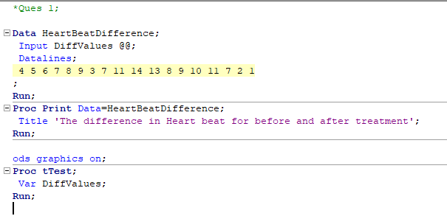

**Log:**

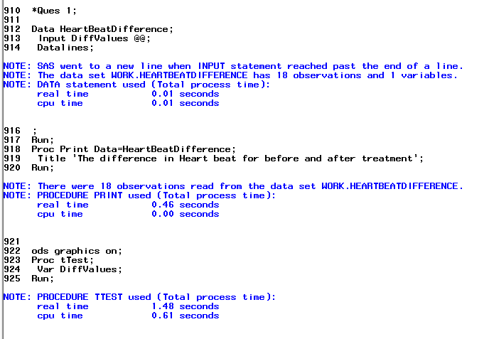

**Results:**

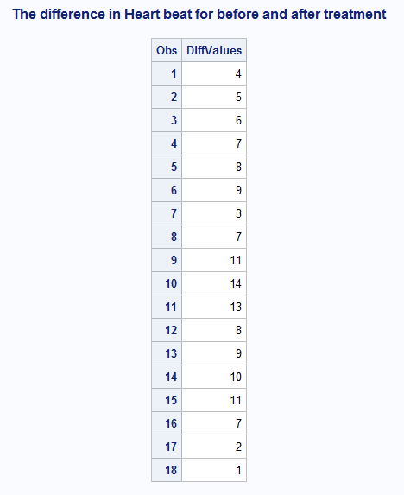

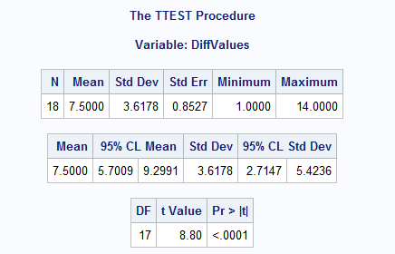

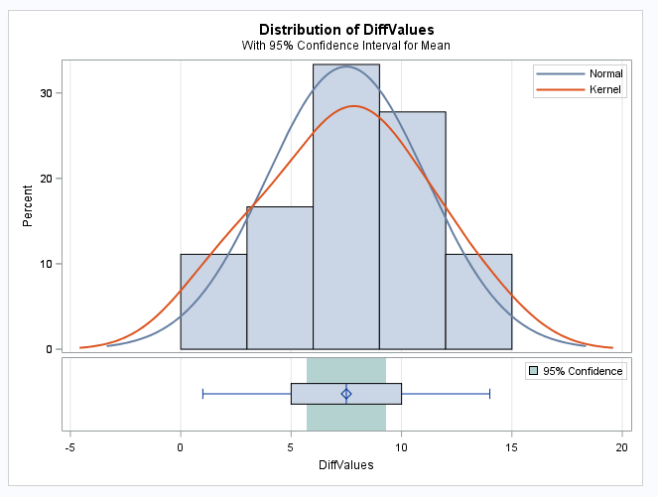

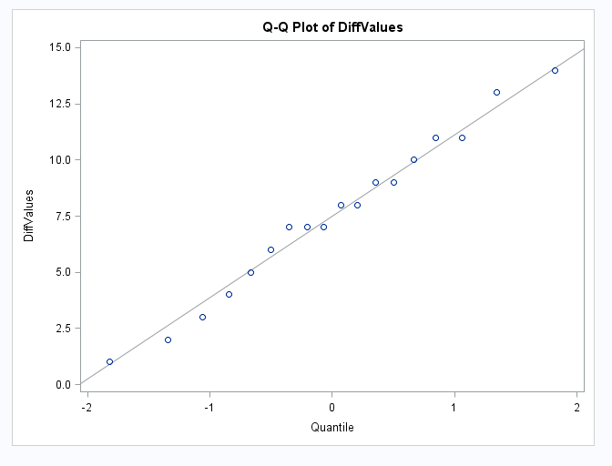

1. Use the SAS data sets Bicycles to produce two vertical charts showing frequencies for Country and Model. Use the PATTERN option VALUE=empty.

**Code:**

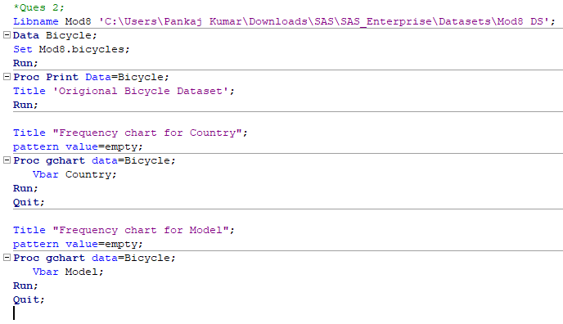

**Log:**

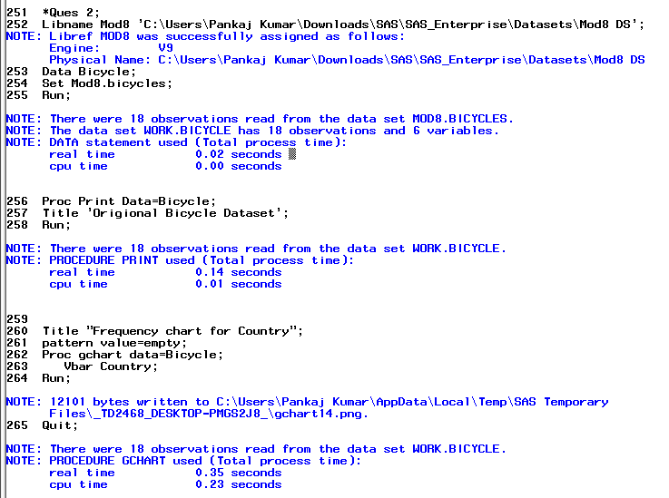

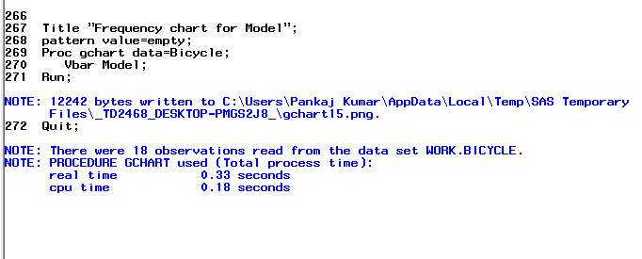

**Results:**

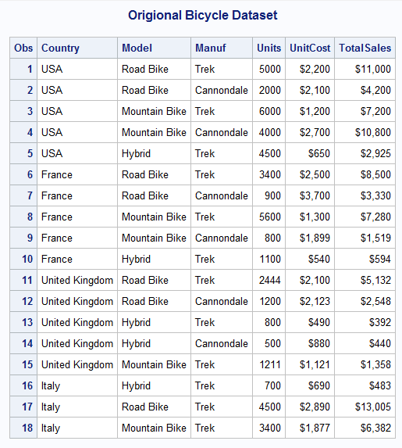

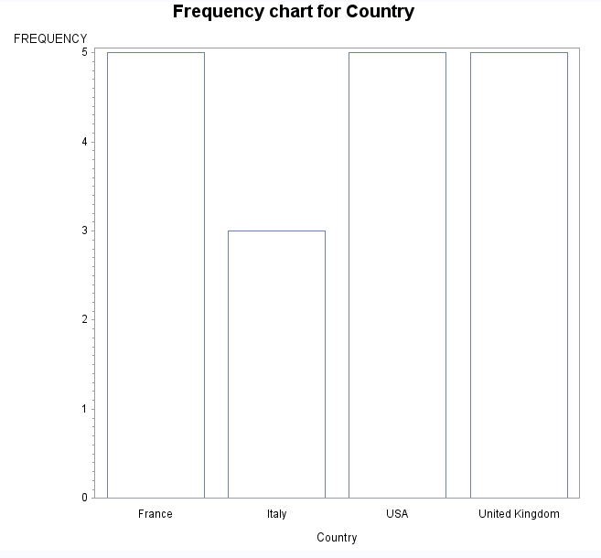

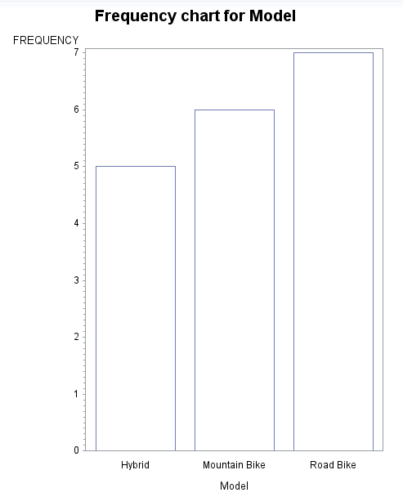

1. Refer to MANATEES data. Plot the total number of manatee deaths in each year on the vertical axis and the year on the horizontal axis. Mark these points on the plot with a T. On the same plot, show the total number of deaths attributed to humans (from all watercraft [WATERC], flood gates [PERIN], canal locks [LOCK], and other human-related deaths [RELAT]) plotted against the year. Mark the human-related fatalities with the character H.

**Code:**

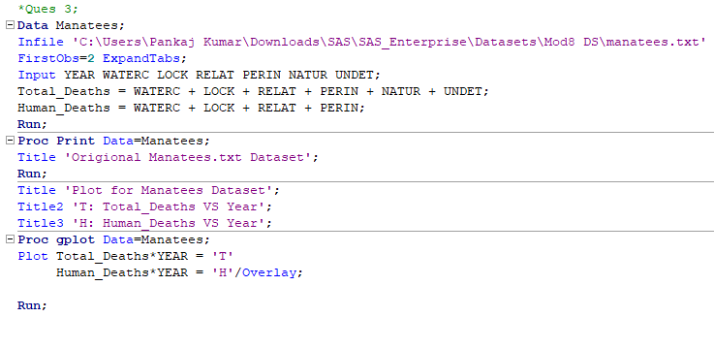

**Log:**

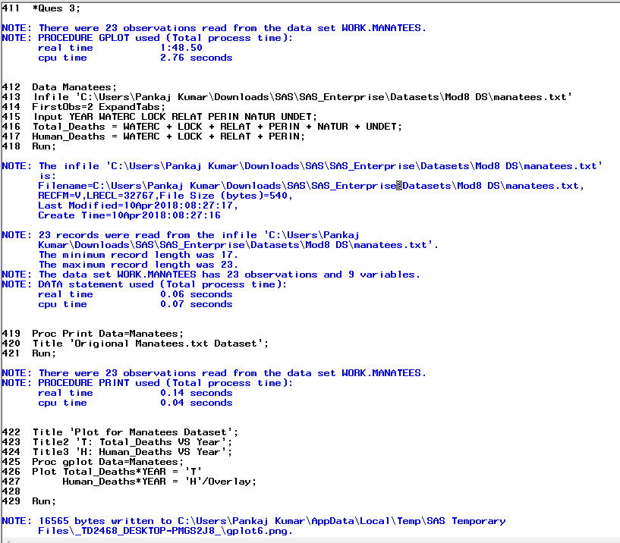

**Results:**

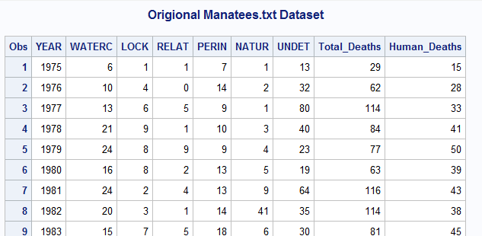

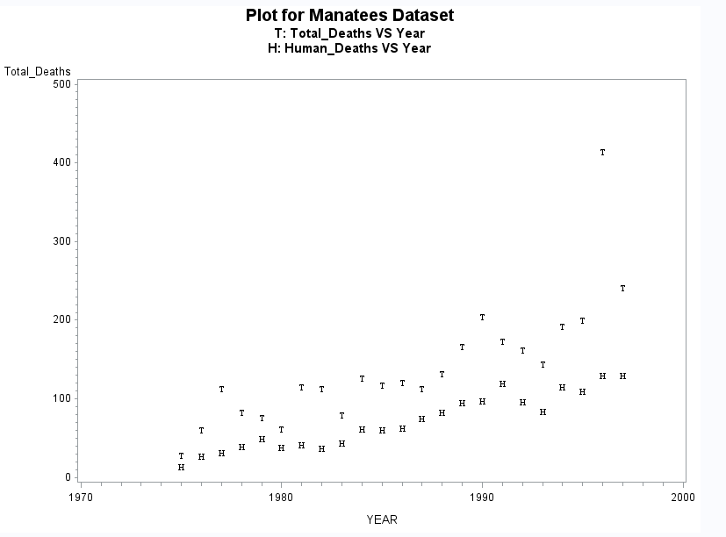

1. Refer to the IRIS data. Create labels for the variables in the dataset. Prepare three scatterplots (one for each iris species) to illustrate the relationship between sepal length (SL) and sepal width (SW) within each species. Use the UNIFORM option so that all 3 plots have the same dimensions for the X- and Y-axes. Add an appropriate descriptive title to the plots.

**Code:**

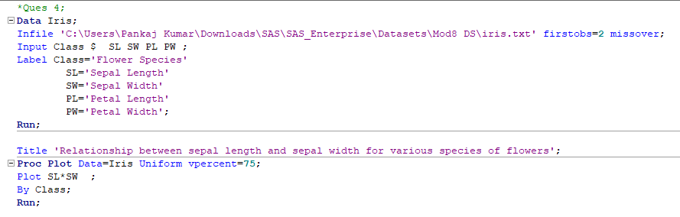

**Log:**

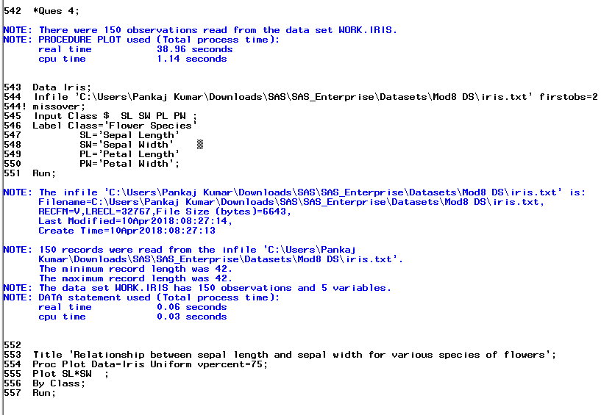

**Results:**

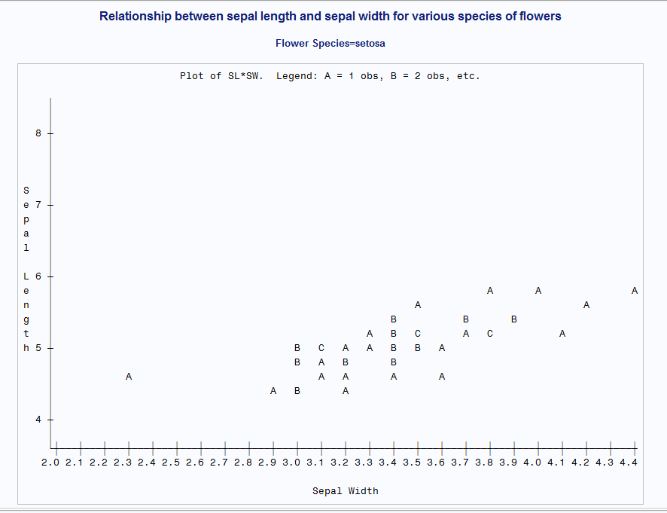

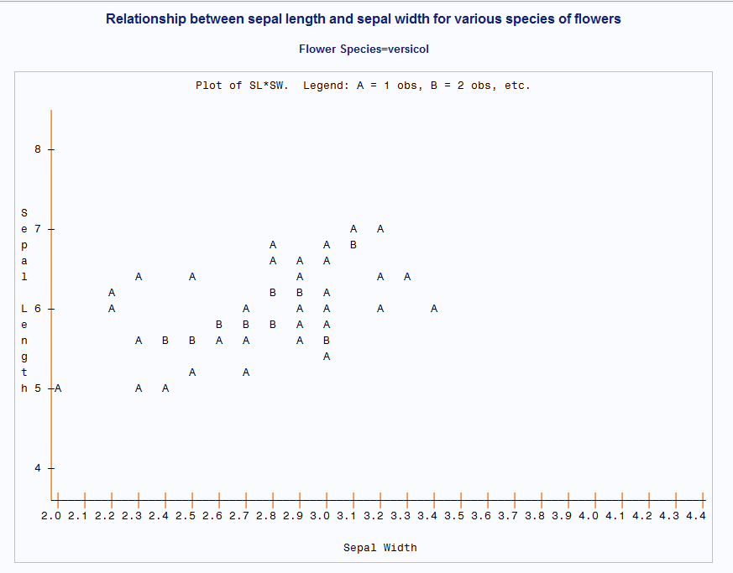

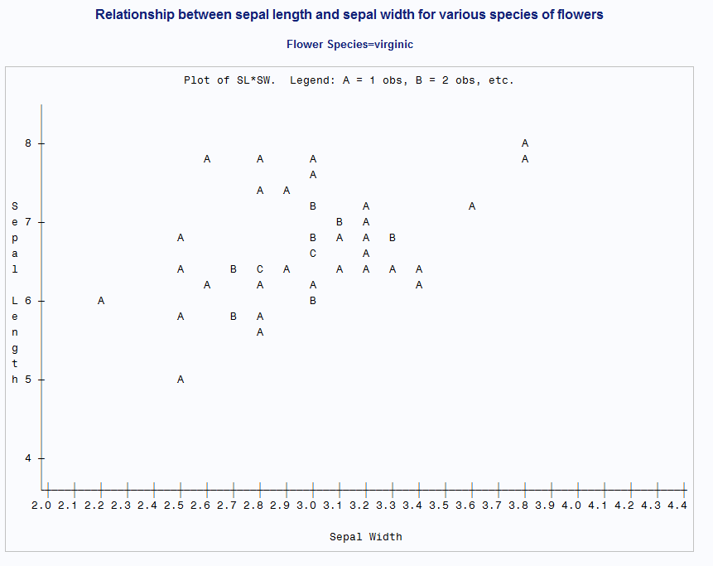

1. Refer to the CLINTON data. Calculate the average percent approval rating for President Clinton in each year from 1992-1998, and plot the average approval rating on the vertical axis versus the year on the horizontal axis.

**Code:**

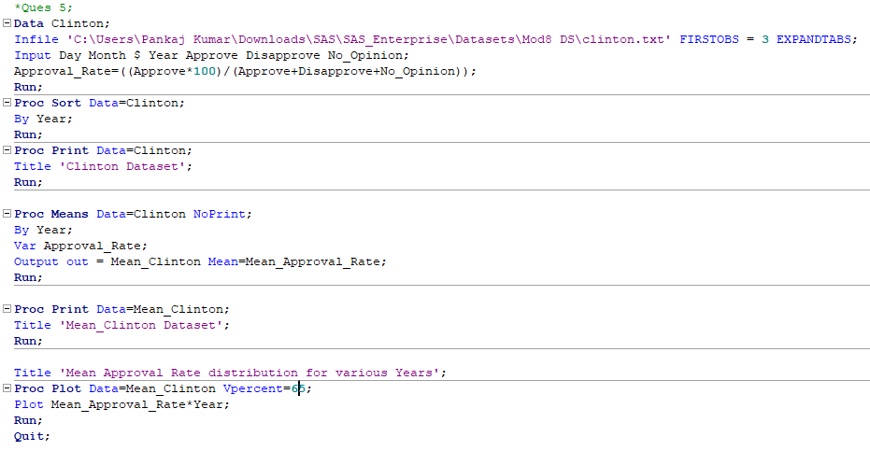

**Log:**

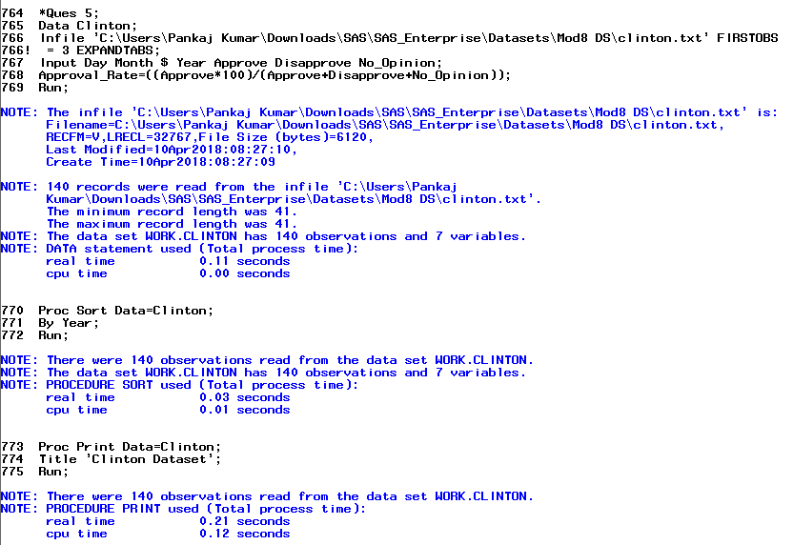

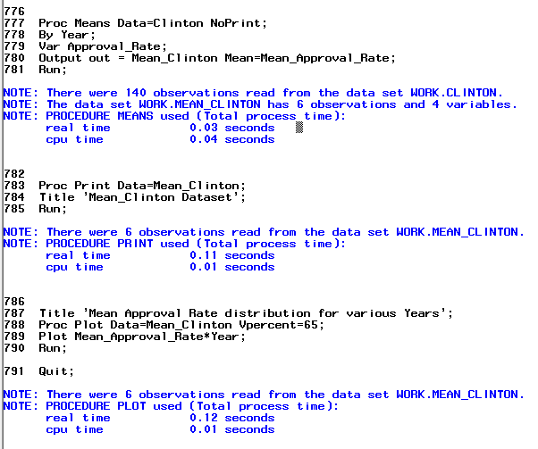

**Results:**

